**DATABASE MANAGEMENT SYSTEM**

**(DBMS-LAB)**

**Schema Commands**

**CREATE SCHEMA COMPANY;**



SHOW DATABASES;

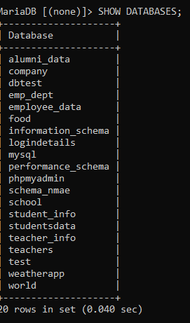

USE COMPANY;



**CREATING TABLE**

EMPLOYEE

CREATE TABLE EMPLOYEE(

-> Fname VARCHAR(15) NOT NULL,

-> Minit CHAR,

-> Lname VARCHAR(15) NOT NULL,

-> Ssn CHAR(9) NOT NULL,

-> Bdate DATE,

-> Address VARCHAR(30),

-> Sex CHAR,

-> Salary DECIMAL(10,2),

-> Super_ssn CHAR(9),

-> Dno INT NOT NULL,

-> PRIMARY KEY(Ssn));

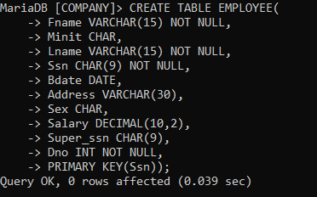

DEPARTMENT

CREATE TABLE DEPARTMENT(

-> Dname VARCHAR(15) NOT NULL,

-> Dnumber INT NOT NULL,

-> Mgr_ssn CHAR(9) NOT NULL,

-> Mgr_start_date DATE,

-> PRIMARY KEY(Dnumber),

-> UNIQUE (Dname),

-> FOREIGN KEY (Mgr_ssn) REFERENCES EMPLOYEE(Ssn) );

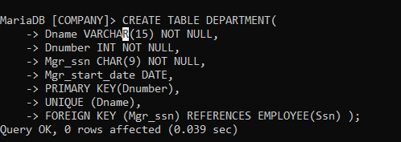

DEPT_LOCATIONS

CREATE TABLE DEPT_LOCATIONS(

-> Dnumber INT NOT NULL,

-> Dlocation VARCHAR(15) NOT NULL,

-> PRIMARY KEY (Dnumber, Dlocation),

-> FOREIGN KEY (Dnumber) REFERENCES DEPARTMENT(Dnumber) );

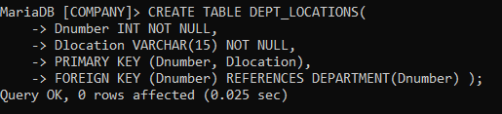

PROJECT

CREATE TABLE PROJECT(

-> Pname VARCHAR(15) NOT NULL,

-> Pnumber INT NOT NULL,

-> Plocation VARCHAR(15) NOT NULL,

-> Dnum INT NOT NULL,

-> PRIMARY KEY (Pnumber),

-> UNIQUE (Pname),

-> FOREIGN KEY (Dnum) REFERENCES DEPARTMENT(Dnumber) );

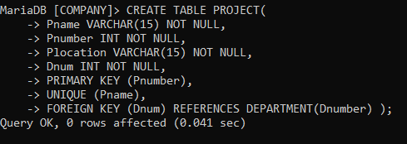

WORKS_ON

CREATE TABLE WORKS_ON(

-> Essn CHAR(9) NOT NULL,

-> Pno INT NOT NULL,

-> Hours DECIMAL(3,1) NOT NULL,

-> PRIMARY KEY (Essn, Pno),

-> FOREIGN KEY (Essn) REFERENCES EMPLOYEE(Ssn),

-> FOREIGN KEY (Pno) REFERENCES PROJECT(Pnumber) );

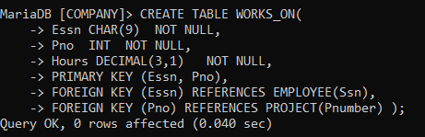

DEPENDENT

CREATE TABLE DEPENDENT(

-> Essn CHAR(9) NOT NULL,

-> Dependent_name VARCHAR(15) NOT NULL,

-> Sex CHAR,

-> Bdate DATE,

-> Relationship VARCHAR(8),

-> PRIMARY KEY (Essn, Dependent_name),

-> FOREIGN KEY (Essn) REFERENCES EMPLOYEE(Ssn) );

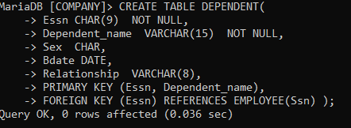

**SHOW TABLES IN THE DATABASE**

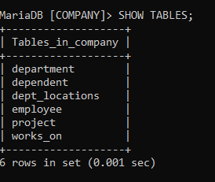

**SHOWING TABLES THROUGH DESC COMMAND**

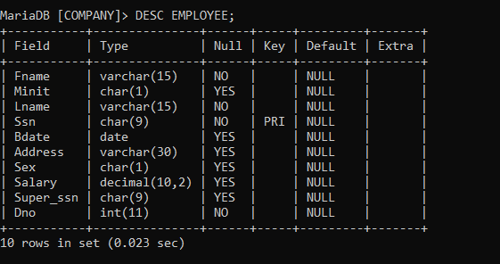

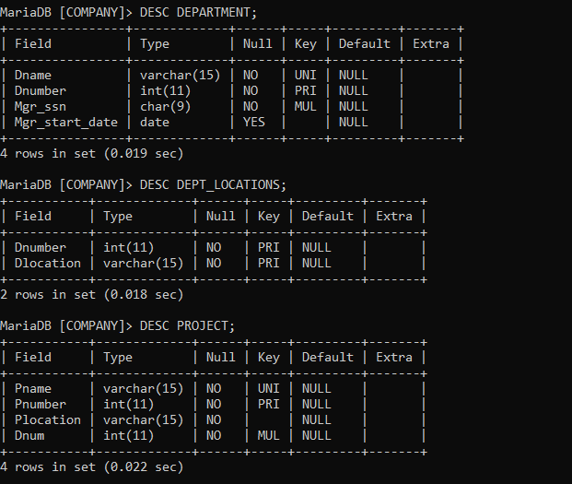

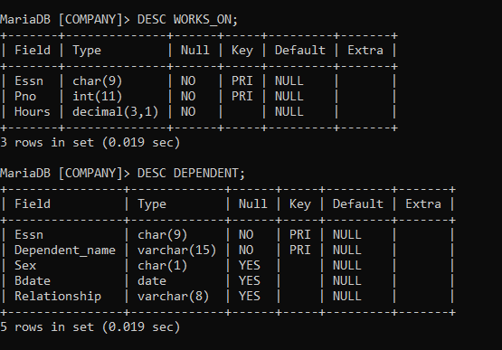

**INSERTING VALUES IN THE TABLES**